EXECUTIVE COMMITTEE MEMBERS - 2022-2025
Sl. No. | Name | Designation | State | Photo
1. | Prof. Javed Ahmad | President | Delhi | 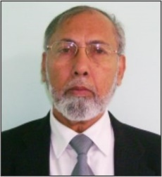
2. | Dr. M.K. Sahani | Vice President | Bihar | 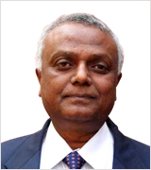
3. | Dr. Ashwani Wanganeo | Vice President | Jammu & Kashmir | 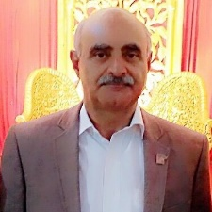
4. | Dr. Tanu Jindal | Vice President | Uttar Pradesh | 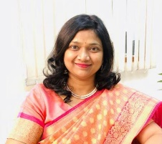
5. | Prof. Altaf Ahmad | Vice President | Uttar Pradesh | 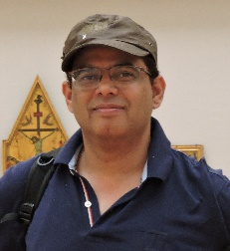
6. | Dr. Prabhakar Ranjan | Joint Secretary | Uttar Pradesh | 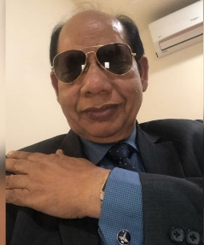
7. | Dr. Dinesh Rangappa | Joint Secretary | Karnataka
8. | Dr. Syed Shabih Hassan | Joint Secretary | Punjab | 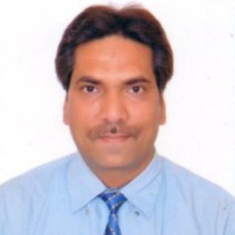
9. | Prof. Shakeel Ahmad Khan | General Secretary | New Delhi | 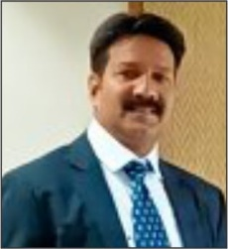
10. | Mr. R.K. Sinha | Executive Secretary | New Delhi | 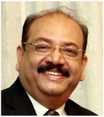
11. | Dr. Ram Sewak Singh Tomar |  | Uttar Pradesh | 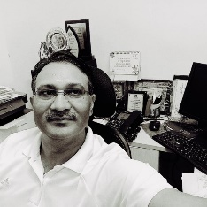
12. | Dr. Shri Prakash | Executive Committee Member | Uttar Pradesh | 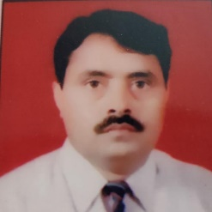
13. | Dr. Pramod Kumar | Executive Committee Member | Himachal Pradesh | 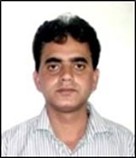
14. | Dr. Mamta Kumari | Executive Committee Member | Bihar | 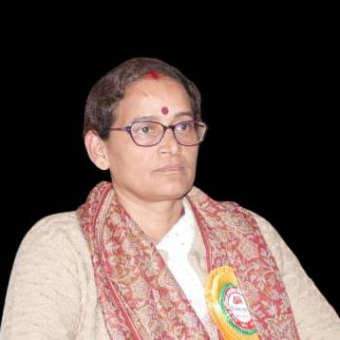
15. | Dr. Gaurav Saxsena | Executive Committee Member | Himachal Pradesh | 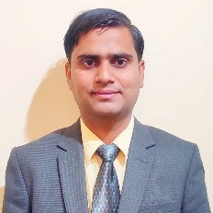
16. | Dr. Ashok Dhakad | Executive Committee Member | Punjab | 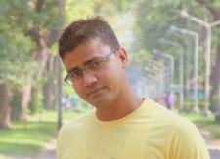
17. | Dr. Balwan Rawat | Executive Committee Member | Uttarakhand
18. | Dr. Suraj Tripathi | Executive Committee Member | Odisha | 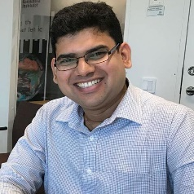
19. | Mrs. Vandana Sinha | Executive Committee Member | Delhi | 