EC Members (2025-28)
Sl. No. | Name | Designation | Address | Photo
1. | Prof. Altaf Ahmad | President | Delhi | 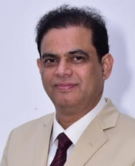
2. | Dr. Tanu Jindal | Vice President | Uttar Pradesh | 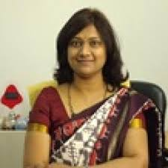
3. | Dr. Vijay K. Yadav | Vice President | Uttar Pradesh | 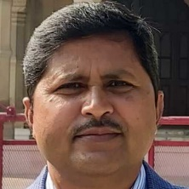
4. | Dr. Syed Shabih Hassan | Vice President | Punjab | 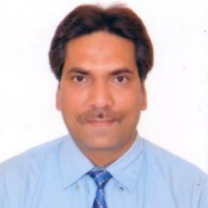
5. | Dr. Prabhakar Ranjan | Vice President | Uttar Pradesh | 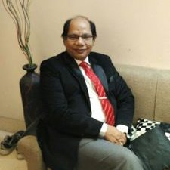
6. | Dr. Dinesh Rangappa | Vice President | Karnataka | 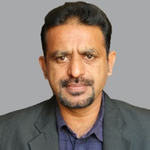
7. | Dr. Iqbal Raja Khan | Joint Secretary | Delhi | 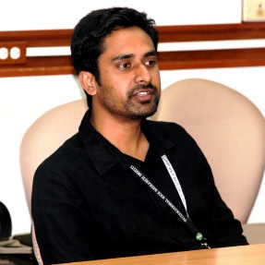
8. | Dr. Gaurav Saxena | Joint Secretary | Madhya Pradesh | 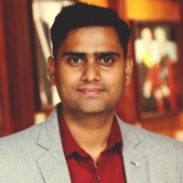
9. | Dr. R.S. Tomar | Joint Secretary | Uttar Pradesh | 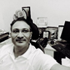
10. | Dr. Sushma Tiwari | Joint Secretary | Madhya Pradesh | 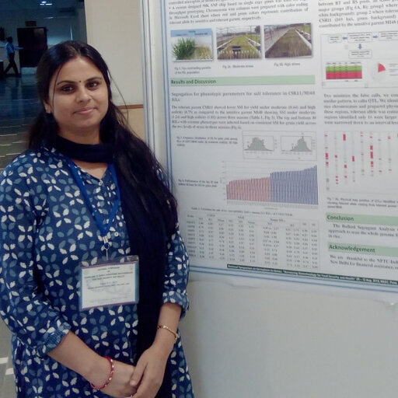
11. | Dr. Rachna Dubey | Joint Secretary | Bihar | 
12. | Prof. Shakeel Ahmad Khan | General Secretary | Delhi | 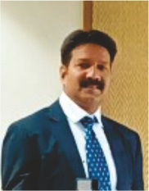
13. | Dr. Vaibhav K. Singh | Treasurer | Delhi | 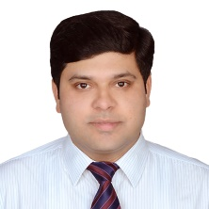
14. | Dr. R.K. Sinha | Executive Secretary | Delhi | 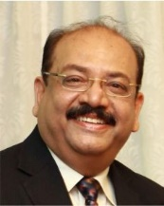
15. | Prof. Pallabh K. Haldar | Exe. Comm. Member | West Bengal | 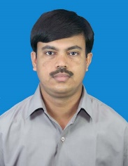
16. | Prof. Shri Prakash | Exe. Comm. Member | Uttar Pradesh | 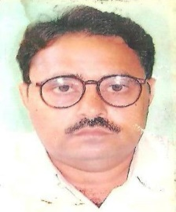
17. | Dr. Prasanna D.S. | Exe. Comm. Member | Karnataka | 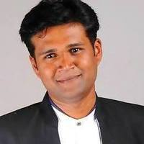
18. | Dr. Mohd. Tasleem | Exe. Comm. Member | Delhi | 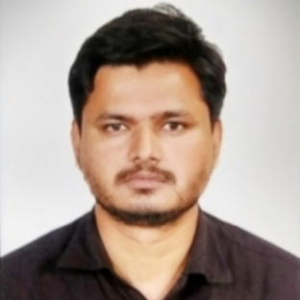
19. | Dr. Rajkumar Yadav | Exe. Comm. Member | Uttar Pradesh | 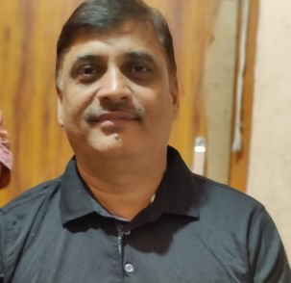
20. | Dr. Sushil Kumar | Exe. Comm. Member | Uttar Pradesh | 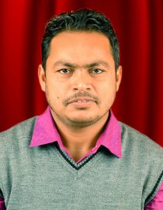
21. | Dr. Ashok Dhakad | Exe. Comm. Member | Punjab | 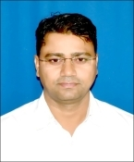
22. | Dr. Rajiv Nandan | Exe. Comm. Member | Uttar Pradesh | 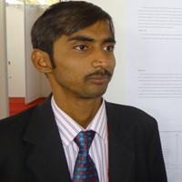
23. | Mrs. Vandana Sinha | Exe. Comm. Member | Delhi | 